TEMPLATE AND INSTRUCTIONS FOR FULL PAPER

Name Surname^{1,*}, Name Surname², Name Surname³
¹Institution, Address, Country
²Institution, Address, Country

*Corresponding e-mail: xxxxx@xxxxxxx

ABSTRACT – This is the template and instructions for abstracts. Authors are advised to read the extended abstract guidelines carefully and follow them strictly. The maximum number of words for the short abstract is 100 words.

Keywords: One; two; three (maximum of three keywords)

- INTRODUCTION
The full paper should be written in English including figures, tables and references.
It should be max 8-pages in length.

- METHODOLOGY
The methodology must be clearly stated and described in sufficient detail or with sufficient references.

- RESULTS AND DISCUSSION
The findings and arguments of the work should be explicitly described and illustrated. All the tables, images and figures should be centered. Figures and images should be numbered and figure headers should be placed under the figure or image; as for the tables, they should also be numbered and the table header should be placed at the top.

Format for table and figure are as in Table 1 and Figure 1.

Table 1 Table caption
Properties | Data
xxxx | 1234
xxxx | 1234

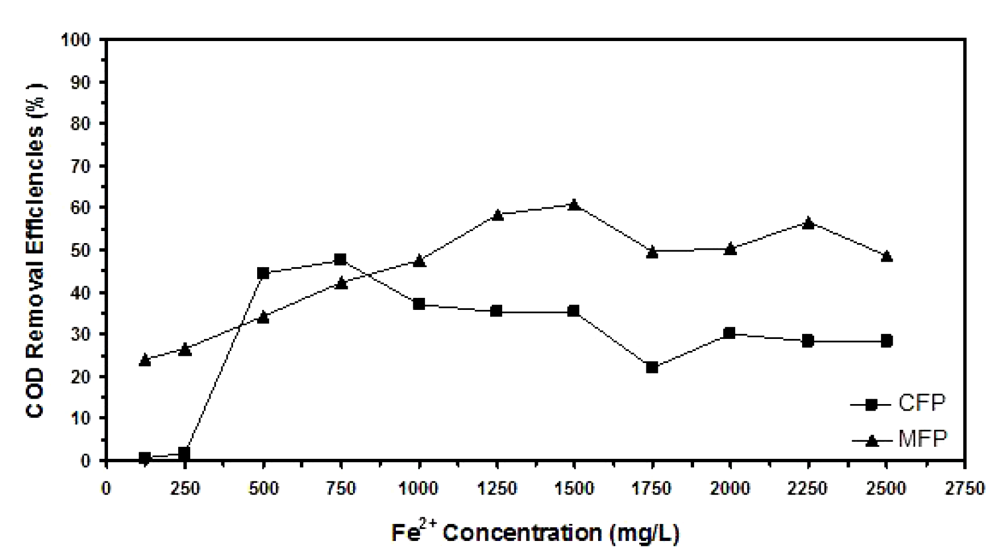
Figure 1 One-column illustration

CONCLUSIONS
Conclusions should include the principles and generalisations inferred from the results, any exceptions to, or problems with these principles and generalisations, theoretical and/or practical implications of the work, and conclusions drawn and recommendations

ACKNOWLEDGEMENT
The authors would like to express appreciation for the support of the sponsors [Project Number = XXXXXXX

REFERENCES

Format for references must be in the following style:

Journal articles

{1] Anco, S., Wald, R., Does there exist a sensible quantum theory of an algebravalued scalar field, Phys. Rev., 39, 2297-2307, 1989.

Conference papers

[1] Seman B, Hamad S, and M.A. Azam, Proceedings of Innovative Research and Industrial Dialogue 2016, 2016, pp. 19–20.

Books

[1] Strunk Jr, and White B, The elements of style, 4th ed. New York: Longman; 2000.

